

Lab assignment no: 2
Tayyaba Hussain
SP24-BSE-059
Information security (lab)
BS software engineering

Lab task 1:
You have implemented DES there is built in implemented DES in python in crypto cipher module use it for encryption/decryption and provide output sample example.
Code: 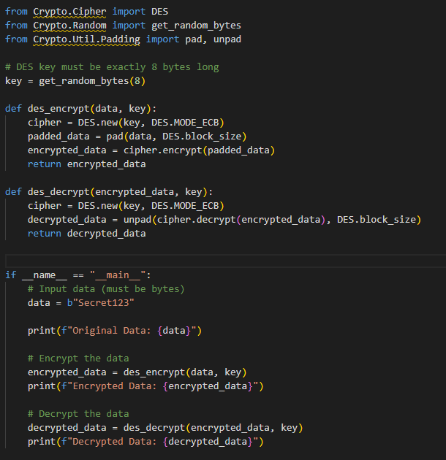
Output: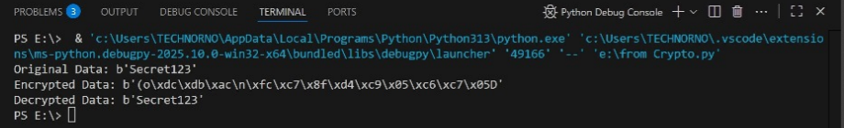

LAB TASK 2 BELOW

Lab task 2:
“Question 1: Vernam-style Stream Cipher”
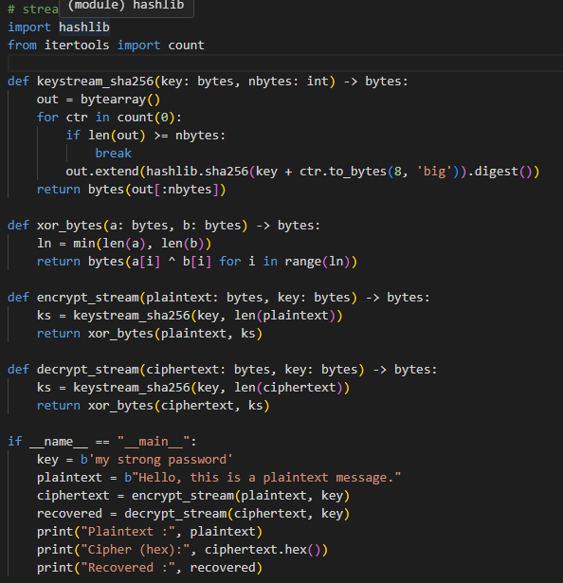
Output:
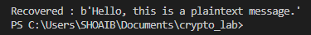

“Question 2: Two-time-pad (Key Reuse) Attack”
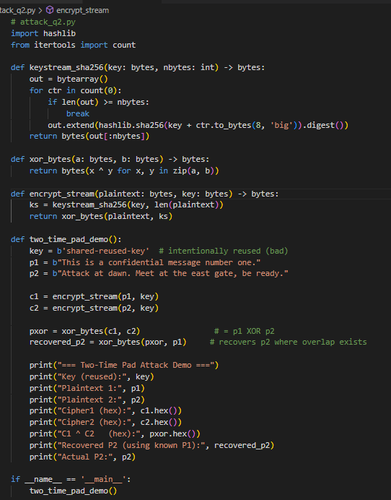
Output:
MITM Attack (2DES):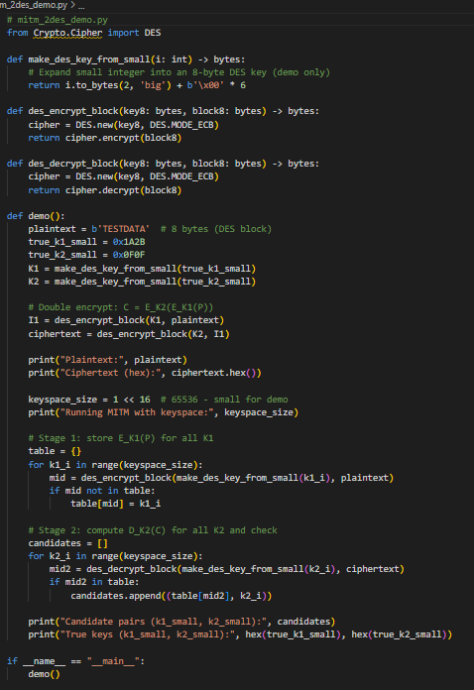
Output:
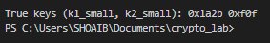
“Home Task: AES”
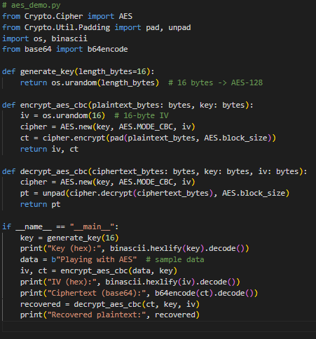
Output:
